ТАНИЯРОВА Айсулу Бахитовна,
Зоя Космодемьянская атындағы №23 мектеп-лицейінің ағылшын тілі пәні мұғалімі.
Шымкент қаласы

MY COUNTRY. ABAI QUNANBAIULY.

Learning objectives(s) that this lesson is contributing to |  | 9.S7 use appropriate subject-specific vocabulary and syntax to talk about an increased range of general and curricular topics  9.UE3 use a variety of compound adjectives, adjectives as participles, comparative structures indicating degree, and intensifying adjectives on a wide range of familiar general and curricular topics  9.R5 deduce meaning from context in short texts on a limited range of familiar general and curricular topics
Lesson objectives |  | All learners will be able to:  - Identify the theme, new words and use them as the basis for discussion.  - Respond to and discuss the reading passage using interpretive, evaluative and creative thinking skills.  - Make a presentation about famous poets. Respond to and discuss the reading passage using interpretive, evaluative and creative thinking skills.
Plan
Planned timings | Teacher’s activities |  | Student’s activities | Marks | Resources
Beginning the lesson  5 min.  5 min. | Org.moment  The lesson greeting.  Warm up.  It’s time to think It’s time to speak  It’s time to show We are ready Let’s go!  Dividing into two groups  Asking homework  Teacher asks some questions  - Holiday advices  - What should you remember when you park?  - How can you avoid getting sunburnt?  - What do local people appreciate?  - What should you consider when you buy souvenirs?  - Trip  - Travel  - Voyage  Introduction of the new lesson  ІІ.«Abai.A GREAT KAZAKH POET»  (Бейне- ролик )  Brainstorming:  - Dear children! Look at the screen.  Abai is – unique!  Abai is – wise!  My Abai is only in the world.  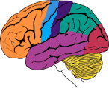  So, boys and girls! Today’s our lesson is My country. Abai Kunanbaev. Open your books and copy-books. Write down today’s day and date.  Today we’ll speak about a great Kazakh poet, musician, and a writer Abai Kunanbaev And now, I’ll give you tasks.  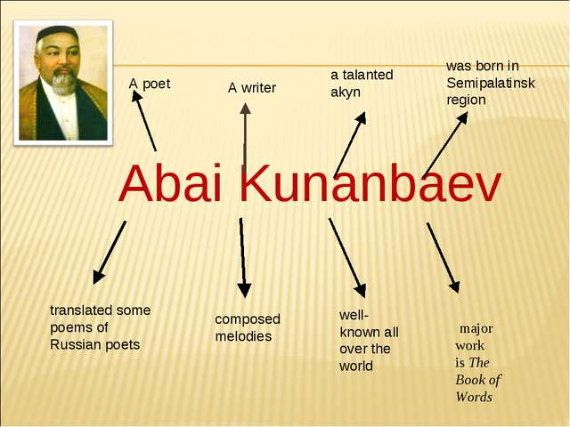 |  | Sts warm greet the teacher  Taking students own things  Put the words in the correct order  Sts answer around the class. | Emoticon  Individual  work  Oral  1  Pair work  Oral  1 | Slide (useful phrases)  objects  Video  Says about Abai
Main  Activities  30 min | LISTENING and READING TASKS:  Vocabulary  Translator- аудармашы  Oriental classical literature- Шығыс классикакалық әдебиеті  Important art – маңызды өнер  Secondary education-  Accepted— қабылдады  Religious school- діни мектеп  Decided – шешім қабылдады  Local community- жергілікті қауымдастық  Sign— белгі  Fictional story- ойдан шығарылған  Wise – ақылды дана  Spiritual -рухани  Listen and read the text quickly. What interesting facts about a great person have you learnt?  Method: Find and say  Date Facts  1845 He was born near Semipalatinsk  Task 3 Method “Bimgo”  - Read the text again and answer the questions.  - 1 What sort of literature did Abai study at school?  - 2 Why did he stop working with his father?  - 3 When did he start writing poetry?  - 4 Which authors did he translate?  - 5 What genre of book is The Book of Words  Passage Picker(Body-Kinesthetic Intelligence).  Task 2: Choose a paragraph that you think your group would like to re-read.  Descriptors:  1. Choose an interesting or important paragraph and write down its location.  2. Read passage aloud yourself (using body language), or ask someone else to read it, or ask the group to read it silently a  Warm –up  Sing a song  Task 3 :Find true or false .  - 2.18 Read and listen to the text.  Are the sentences true or false?  1 Abai Kunanbaiuly studied Russian authors at  primary school.  2 His father was important in the local town.  3 When he was twenty-eight, he changed career.  4 He wrote the poem Summer when he was  twelve.  5 He wrote fifty books in Russian  6 He changed how people learned and enjoyed  stories in Kazakhstan​  - Descriptor:  - Learner finds the sentence true or false.  Task 4: Activity “Gallery”  Descriptors:  1. Write at least 2 sentences. Make connections with your own experience, another text or the world.  2. Give evidence from the book to support your connection.  Post-reading stage.  Next, students complete peer-evaluation form.  Ex.2 – 3  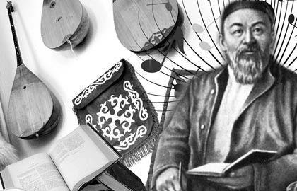  What other Kazakh writers and poets do you know?  Assessment criteria:  Identify the main idea in extended talks with little support.  Apply topic related vocabulary in speech appropriately arranging words and phrases into well-formed sentences.  Demonstrate the ability to participate in a conversation. |  | Ss repeat the words  Ss and elicit their comments at the end  Ss to tell the class.  Students sing a song  Individual work  Students goes around  Ss and elicit their comments at the end  Ss to tell the class. | Emoticon  Formative assessment  Oral  Pair work  2  Oral  Group work  1 point  Writing  Group work  2  Oral  Writing  2  Oral  2  Oral | Student Book p.64  Pair work.  Student Book p.66  Writing worksheet  Student Book p.64  Writing  Worksheets  Writing  Worksheets  Student Book p.64  Ex.1 – 3 p.64
Ending the lesson  5 min. | T: My dear, do you like this lesson? What about we learned? Yes, you are right.  Now, our lesson is over. Thank you for your good job!  Giving the home task. W.B.p.42, Kazakh writers( a report)  Reflection:  "Feedback "  At the end of a lesson learners share with their partner:  - Three new things they have learnt  - What they found easy  - What they found difficult  - Something they would like to learn in the future.

